**Project Planning Phase**

**Project Planning Template (Product Backlog, Sprint Planning, Stories, Story points)**

|  |  |
| --- | --- |
| Date | 27 October 2023 |
| Team ID | PNT2023TMID591061 TEAM-591061 |
| Project Name | Project - Wanderlust: A Personalized Travel Planning And Tracking App |
| Maximum Marks | 8 Marks |

**Product Backlog, Sprint Schedule, and Estimation (4 Marks)**

Use the below template to create product backlog and sprint schedule

|  |  |  |  |  |  |  |
| --- | --- | --- | --- | --- | --- | --- |
| **Sprint** | **Functional**  **Requirement (Epic)** | **User Story**  **Number** | **User Story / Task** | **Story Points** | **Priority** | **Team**  **Members** |
| Sprint-1 | Registration and Login | USN-1 | As a user, I can register for the application by entering my email, password, and confirming my password. | 2 | High | Akriti, Shreya, Sanjana |
| Sprint-1 | Registration and Login | USN-2 | As a user, I can register for the application through Gmail. | 1 | High | Akriti, Shreya, Sanjana |
| Sprint-1 | Registration and Login | USN-3 | As a user, I can register for the application through Facebook. | 2 | Low | Akriti, Shreya, Sanjana |
| Sprint-1 | Registration and Login | USN-4 | As a user, I can register for the application through Gmail | 2 | Medium | Akriti, Shreya, Sanjana |
| Sprint-1 | Dashboard | USN-5 | As a user, I can see a dashboard that displays my upcoming trips, saved destinations, and travel inspiration. | 3 | High | Akriti, Shreya, Sanjana |
| Sprint 2 | Personalized Travel Profile | USN-6 | As a user, I can create a personalized travel profile by specifying my travel interests, budget, preferred destinations, and travel style. | 4 | High | Akriti, Shreya, Sanjana |
| Sprint 2 | Inspiration and Discovery | USN-7 | As a user, I can browse a curated feed of travel inspiration, including destination highlights, travel stories, and user-generated content. | 4 | High | Akriti, Shreya, Sanjana |
| Sprint 3 | Smart Itinerary Planning | USN-8 | As a user, I can create a new itinerary by adding flights, accommodations, activities, and dining options. | 4 | Medium | Akriti, Shreya, Sanjana |
| Sprint 3 | Smart Itinerary Planning | USN-9 | As a user, I can view my itinerary in a calendar view and make changes as needed. | 4 | High | Akriti, Shreya, Sanjana |
| Sprint 4 | Real-Time Updates and Navigation | USN-10 | As a user, I can receive real-time updates on my itinerary, including gate changes, weather alerts, and traffic information. | 4 | High | Akriti, Shreya, Sanjana |
| Sprint 4 | Real-Time Updates and Navigation | USN-11 | As a user, I can use the app's offline maps and navigation assistance to explore without an internet connection. | 4 | High | Akriti, Shreya, Sanjana |
| Sprint 5 | Trip Journal and Memories | USN-12 | As a user, I can add photos, videos, and written entries to my trip journal. | 3 | Medium | Akriti, Shreya, Sanjana |
| Sprint 5 | Shareable Travel Stories | USN-13 | As a user, I can compile my trip journal into a shareable story. | 3 | High | Akriti, Shreya, Sanjana |
| Sprint 6 | User Community | USN-14 | As a user, I can connect with other travelers in the app's community. | 3 | High | Akriti, Shreya, Sanjana |
| Sprint 6 | Booking Integration | USN-15 | As a user, I can book flights, accommodations, and activities directly from the app. | 4 | Medium | Akriti, Shreya, Sanjana |
| Sprint 7 | Security and Safety Features | USN-16 | As a user, I can view and update my emergency contact information in the app. | 2 | High | Akriti, Shreya, Sanjana |
| Sprint 7 | Security and Safety Features | USN-17 | As a user, I can view local emergency service details in the app. | 2 | Medium | Akriti, Shreya, Sanjana |
| Sprint 8 | Multi-Platform Access | USN-18 | As a user, I can access my travel plans and memories on my smartphone, tablet, and desktop computer. | 4 | Medium | Akriti, Shreya, Sanjana |

**Project Tracker, Velocity & Burndown Chart: (4 Marks)**

|  |  |  |  |  |  |  |
| --- | --- | --- | --- | --- | --- | --- |
| **Sprint** | **Total Story**  **Points** | **Duration** | **Sprint Start Date** | **Sprint End Date**  **(Planned)** | **Story Points**  **Completed (as on Planned End Date)** | **Sprint Release Date**  **(Actual)** |
| Sprint-1 | 20 | 6 Days | 9 Oct 2023 | 14 Oct 2023 | 20 | 14 Oct 2023 |
| Sprint-2 | 20 | 4 Days | 15 Oct 2023 | 18 Oct 2023 | 20 | 18 Oct 2023 |
| Sprint-3 | 20 | 4 Days | 19 Oct 2023 | 22 Oct 2023 | 20 | 22 Oct 2023 |
| Sprint-4 | 20 | 4 Days | 23 Oct 2023 | 26 Oct 2023 | 20 | 27 Oct 2023 |
| Sprint-5 | 20 | 3 Days | 27 Oct 2023 | 29 Oct 2023 | 20 | 29 Oct 2023 |
| Sprint-6 | 20 | 4 Days | 30 Oct 2023 | 2 Nov2023 | 20 | 2 Nov2023 |
| Sprint-7 | 20 | 4 Days | 3 Nov 2023 | 6 Nov 2023 | 20 | 6 Nov 2023 |
| Sprint-8 | 20 | 2 Days | 7 Nov 2023 | 8 Nov 2023 | 20 | 8 Nov 2023 |

**Velocity:**

Imagine we have a 10-day sprint duration, and the velocity of the team is 20 (points per sprint). Let’s calculate the team’s average velocity (AV) per iteration unit (story points per day)



**Burndown Chart:** A burn down chart is a graphical representation of work left to do versus time. It is often used in agile software development methodologies such as Scrum. However, burn down charts can be applied to any project containing measurable progress over time.

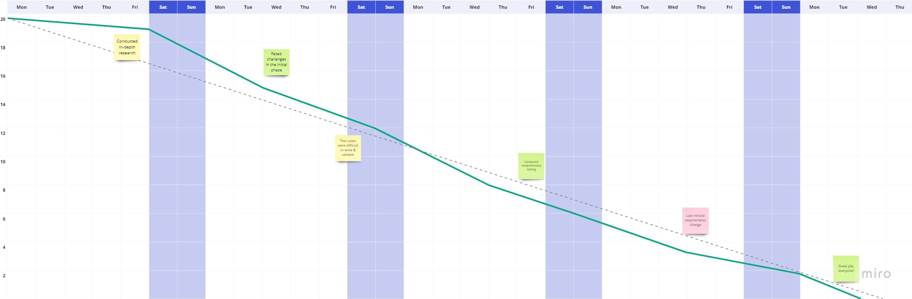



**https://www.visual-paradigm.com/scrum/scrum-burndown-chart/**

**https://www.atlassian.com/agile/tutorials/burndown-charts**

**https://www.atlassian.com/agile/project-management**

**https://www.atlassian.com/agile/tutorials/how-to-do-scrum-with-jira-software**

**https://www.atlassian.com/agile/tutorials/epics**

**https://www.atlassian.com/agile/tutorials/sprints**

**https://www.atlassian.com/agile/project-management/estimation**

**https://www.atlassian.com/agile/tutorials/burndown-charts**